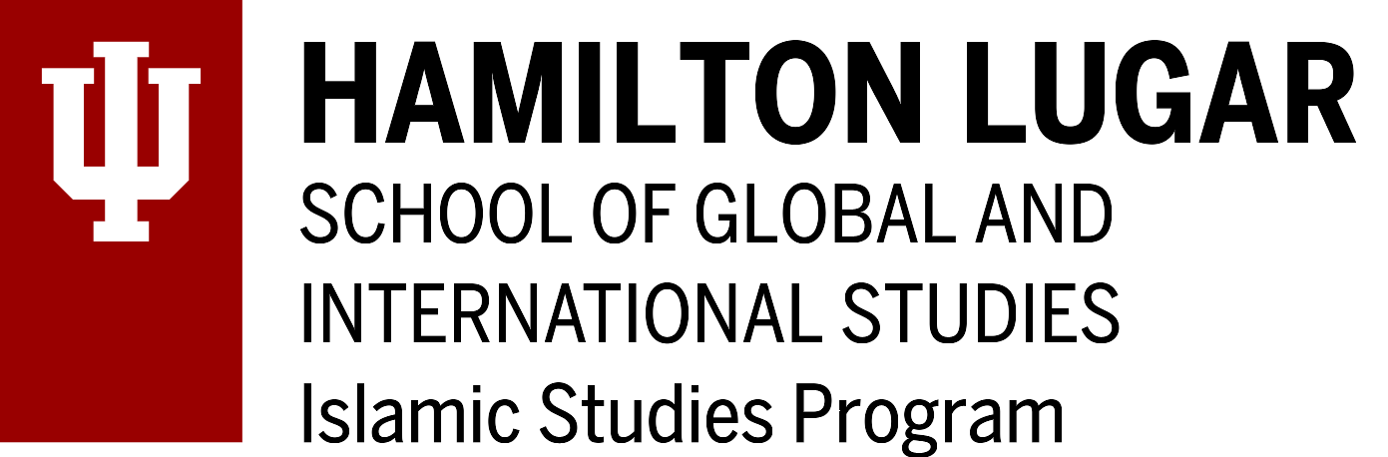
Grant-in-Aid for IU Faculty

Deadline: March 18, 2020 for the period March 18, 2020—July 31, 2020

Applicant’s Name: _________________________________________ Dept.: ____________________

Previously awarded an Islamic Studies Program Grant-in-Aid award?: (Yes or No)

Please describe below your proposed project / travel objectives, etc. in 500 words or less (e.g., if support is sought for travel to an academic gathering please note the gathering’s title, venue, dates, title of your panel and paper; if traveling to an archive/field work, etc., please note destination, dates, and objectives; if seeking subvention funds, please note exactly what the funds will be used for; etc.). Important: If your work’s relevance to Islamic Studies is not self-evident, please make sure to elaborate on its relevance.

Note: If available, please include supporting material (e.g., letters of invitation; confirmation of paper acceptance, etc.) with your application.

The Islamic Studies Program requests that you acknowledge our support in any product of your research, when appropriate.

Date: ______________ Applicant’s signature: _______________________
(an electronic signature is valid)
Proposed Project / Travel Objectives description:

