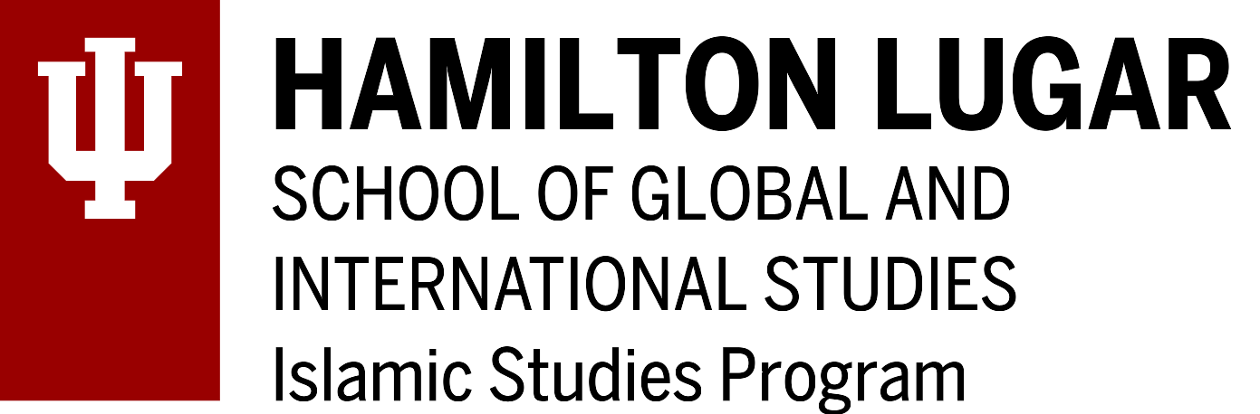
Grant-in-Aid for IU Faculty

Deadline: April 1, 2024 for the period
April 15, 2024—August 25, 2024

Applicant’s Name: _________________________________________ Dept.: ____________________

Previously awarded an Islamic Studies Program Grant-in-Aid award? (Yes or No):

Please describe below your proposed project / travel objectives, etc. in 500 words or less (e.g., if support is sought for travel to an academic gathering please note the gathering’s title, venue, dates, title of your panel and paper; if traveling to an archive/field work, etc., please note destination, dates, and objectives; if seeking subvention funds, please note exactly what the funds will be used for; etc.).

Important: If your work’s relevance to Islamic Studies is not self-evident, please make sure to elaborate on its relevance.

If available, please include supporting material (e.g., letters of invitation; confirmation of paper acceptance, etc.) with your application.

Please note: We follow IU travel guidelines.

The Islamic Studies Program requests that you acknowledge our support in any product of your research, when appropriate.

Date: __________________

Proposed Project / Travel Objectives description:

